**R4DCB08 modbus rtu protocol**

**Function code**

|  |  |  |  |  |
| --- | --- | --- | --- | --- |
| RS485 address  (Station address)  (1) | Function (1) | Register address (2) | Read number (2) | CRC16 (2) |
|  | 03 Read |  |  |  |
|  | 06 Write |  |  |  |

|  |  |  |  |  |
| --- | --- | --- | --- | --- |
| Read-only register,Read Function code Is 03 | | | | |
| Register address | Register contents | Number of bytes | Units | Remarks |
| 0x0000 | CH1 temperature value | 2 | 0.1℃ | When the data is 0X8000(32768),  it indicates no sensor or error |
| 0x0001 | CH2 temperature value |
| 0x0002 | CH3 temperature value |
| 0x0003 | CH4 temperature value |
| 0x0004 | CH5 temperature value |
| 0x0005 | CH6 temperature value |
| 0x0006 | CH7 temperature value |
| 0x0007 | CH8 temperature value |
| Read / write register; Read function code is 03 ,Write function code is 06 | | | | |
| 0x0008 | CH1 Temperature correction value | 2 | 0.1℃ | >0 Temperature increase  <0 temperature decrease  Default : 0 |
| 0x0009 | CH2 Temperature correction value |
| 0x000A | CH3 Temperature correction value |
| 0x000B | CH4 Temperature correction value |
| 0x000C | CH5 Temperature correction value |
| 0x000D | CH6 Temperature correction value |
| 0x000E | CH7 Temperature correction value |
| 0x000F | CH8 Temperature correction value |
| 0x00FD | Automatic temperature report | 2 | Second | 0: Query function (default) 1-255: Automatically report, the unit is second.  1: Report every 1 second  2: Report every 2 seconds  10: Report every 10 seconds Maximum interval of 255 seconds |
| 0x00FE | RS485 address  (Station address) | 2 |  | Read Address 0XFF  Write Address 1-247 |
| 0x00FF | Baud rate | 2 |  | 0~4 0:1200  1:2400 2:4800  3:9600（default）  4:19200  5: Factory reset |

**Serial baud rate：9600（**default**），N，8，1**

**Modbus RTU Communication protocol：**

1. **Read temperature**

Send data

|  |  |  |  |  |
| --- | --- | --- | --- | --- |
| RS485 address  (Station address)  (1) | Function (1) | Register address (2) | Read number (2) | CRC16(2) |

Returns data

|  |  |  |  |  |
| --- | --- | --- | --- | --- |
| RS485 address  (Station address)  (1) | Function (1) | Number of bytes (1) | data (n) | CRC16(2) |

RS485 address:0x01-0xFE

Function code 0x03

Register address：0x0000-0x0007 1-8 channel temperature value

Read number：0x0001-0x0008

The return of the temperature data is two bytes，High-bit in the former and low-bit in the post，convert it to decimal and divided by 10, is the current temperature value；The highest bit 1 indicates a negative value， this value directly subtracting 65536，is the current temperature value.

For example: Read CH1 temperature value:

Send data(RS485 address is 1)：01 03 00 00 00 01 84 0A

Returns data：01 03 02 00 DB F8 1F

01 RS485 address，03 Function，02 length，F8 1F crc16

00DB is the temperature value, the highest bit is 0, so the temperature is positive, it is converted to decimal = 219, 219/10=21.9 is the current temperature value；

For example: Read CH2 temperature value:

Send data(RS485 address is 1)：01 03 00 01 00 01 D5 CA

Returns data：01 03 02 FF 90 F9 D8

FF90 is the temperature value, the highest bit is 1, so the temperature is negative, it is converted to decimal = 65424, (65424-65536)/10=-11.2 is the current temperature value

1. **Read the temperature correction value:**

Send data

|  |  |  |  |  |
| --- | --- | --- | --- | --- |
| RS485 address  (Station address)  (1) | Function (1) | Register address (2) | Read number (2) | CRC16(2) |

Returns data

|  |  |  |  |  |
| --- | --- | --- | --- | --- |
| RS485 address  (Station address)  (1) | Function (1) | Number of bytes (1) | data (n) | CRC16(2) |

RS485 address:0x01-0xFE

Function code 0x03

Register address：0x0008-0x000F 1-8 channel temperature correction value

Read number：0x0001-0X0008

Return data: Celsius, you need to divide this value by 10.

The temperature sensor may have an error with the actual temperature. This correction value can correct the error. The unit is 0.1 °C. If the correction value is a positive number, the value is added at the current temperature, and if it is a negative number, the value is subtracted. Setting it to 0 disables this feature.

For example 1: Read CH1 temperature correction value:

send data(RS485 address is 1)：01 03 00 08 00 01 05 C8

Returns data：01 03 02 00 64 B9 AF

0064 is the correction value, which is expressed as decimal in 100, divided by 10 = 10.0 ° C;

For example 2: Read CH2 temperature correction value:

send data(RS485 address is 1)：01 03 00 09 00 01 54 08

Returns data：01 03 02 FF F1 38 30

FF F1 is the correction value, which is expressed as decimal in -15, divided by 10 = -1.5° C;

1. **Set the temperature correction value**

If the temperature of the module deviates from the actual temperature, it can be corrected with this value. >0 temperature increases, <0 temperature decreases.

Send data

|  |  |  |  |  |
| --- | --- | --- | --- | --- |
| RS485 address  (Station address)  (1) | Function (1) | Register address (2) | Setting Content (2) | CRC16(2) |

Returns data

|  |  |  |  |  |
| --- | --- | --- | --- | --- |
| RS485 address  (Station address)  (1) | Function (1) | Register address  (2) | Register value (2) | CRC16(2) |

RS485 address:0x01-0xFE

Function code 0x06

Register address：0x0004

Setting Content：2Bytes

The highest digit indicates a positive or negative sign, 0 indicates positive, and 1 indicates negative, and the unit is 0.1 °C. When the highest bit is 1, it indicates a negative value. In this case, you need to add 1 to this value. You can also subtract 65536 from the value, which is the current temperature value. Prohibit the correction value to set the register to "0X0000"

For example 1: CH1 offset value is set to 2.0 °C

Send frame: 01 06 00 08 00 14 08 07

Return frame: 01 06 00 08 00 14 08 07 The return frame is the same as the send frame.

For example 2:CH2 the offset value is set to -3.0 ° C, 65536-30 = 65506 =0XFFE2

Send frame: 01 06 00 09 FF E2 98 71

Return frame: 01 06 00 09 FF E2 98 71 The return frame is the same as the send frame.

For example 3: CH3 Prohibit the correction value and set the register to "0X0000"

Send frame: 01 06 00 0A 00 00 A9 C8

Return frame: 01 06 00 0A 00 00 A9 C8 The return frame is the same as the send frame.

1. **Read temperature automatic reporting function**

Send data

|  |  |  |  |  |
| --- | --- | --- | --- | --- |
| RS485 address  (Station address)  (1) | Function (1) | Register address (2) | Read number (2) | CRC16(2) |

Returns data

|  |  |  |  |  |
| --- | --- | --- | --- | --- |
| RS485 address  (Station address)  (1) | Function (1) | Number of bytes (1) | data (n) | CRC16(2) |

RS485 address:0x01-0xFE

Function code 0x03

Register address：0x00FD

Read number：0x0001

For example:

send data(RS485 address is 1)：01 03 00 FD 00 01 15 FA

Returns data：01 03 02 00 00 B8 44

01 RS485 address，03 Function，02 length，00 means query function ,

B8 44 crc16

1. **Set temperature automatic reporting function(8 channels set at the same time)**

Send data

|  |  |  |  |  |
| --- | --- | --- | --- | --- |
| RS485 address  (Station address)  (1) | Function (1) | Register address (2) | Setting Content (2) | CRC16(2) |

Returns data

|  |  |  |  |  |
| --- | --- | --- | --- | --- |
| RS485 address  (Station address)  (1) | Function (1) | Register address  (2) | Register value (2) | CRC16(2) |

RS485 address:0x01-0xFE

Function code 0x06

Register address：0x00FD

Setting Content：1Bytes

For example : For example, the current query function should be changed to automatic reporting:

Automatically report in 1 second, send frame (address is 1) 01 06 00 FD 00 01 D9 FA

Automatically report in 2 second, send frame (address is 1) 01 06 00 FD 00 02 99 FB

Automatically report in 3 second, send frame (address is 1) 01 06 00 FD 00 03 58 3B

Automatically report in 4 second, send frame (address is 1) 01 06 00 FD 00 04 19 F9

Automatically report in 5 second, send frame (address is 1) 01 06 00 FD 00 05 D8 39

Automatically report in 10 second, send frame (address is 1) 01 06 00 FD 00 0A 98 3D

Disable reporting function: send frame (address is 1) 01 06 00 FD 00 00 18 3A

For example: set to 1 second to automatically report, and automatically send temperature and humidity data every second;

Example: 01 03 04 01 2F 03 33 8A E3

1. **Read RS485 address**

Send data

|  |  |  |  |  |
| --- | --- | --- | --- | --- |
| RS485 address  (Broadcast address)  (1) | Function (1) | Register address (2) | Read number (2) | CRC16(2) |

Returns data

|  |  |  |  |  |
| --- | --- | --- | --- | --- |
| RS485 address  ( Broadcast address )  (1) | Function (1) | Number of bytes (1) | data (n) | CRC16(2) |

Broadcast address 0xff

Function code 0x03

Register address：0x00FE

Read number：0x0001

For example:

send data：FF 03 00 FE 00 01 F0 24

Returns data：FF 03 02 00 01 50 50

FF Broadcast address，03 Function，02 length，01 is the current module RS485 address , 50 50 crc16

Note: When using this command, only one temperature module can be connected to the RS485 bus, more than one will be wrong!

1. **Write RS485 address**

Send data

|  |  |  |  |  |
| --- | --- | --- | --- | --- |
| RS485 address  (Station address)  (1) | Function (1) | Register address (2) | Setting Content (2) | CRC16(2) |

Returns data

|  |  |  |  |  |
| --- | --- | --- | --- | --- |
| RS485 address  (Station address)  (1) | Function (1) | Register address  (2) | Register value (2) | CRC16(2) |

RS485 address(Slave ID) : 0x01~0xFE

Function code 0x06

Register address：0x00FE

Setting Content：2Bytes(1-247)

For example, The current RS485 address is 1, We need to change the RS485 address to 3:

send data(RS485 address is 1)：01 06 00 FE 00 03 A8 3B

Returns data：01 06 00 FE 00 03 A8 3B

1. **Read baud rate**

Send data

|  |  |  |  |  |
| --- | --- | --- | --- | --- |
| RS485 address  (Station address)  (1) | Function (1) | Register address (2) | Read number (2) | CRC16(2) |

Returns data

|  |  |  |  |  |
| --- | --- | --- | --- | --- |
| RS485 address  (Station address)  (1) | Function (1) | Number of bytes (1) | data (n) | CRC16(2) |

RS485 address(Slave ID) : 0x01~0xFE

Function code 0x03

Register address：0x000FF

Read number：0x0001

For example:

send data(RS485 address is 1)：01 03 00 FF 00 01 B4 3A

Returns data：01 03 02 00 03 F8 45

01 RS485 address，03 Function，02 length，F8 45 crc16

03 means the current baud rate is 9600bps

Baud rate corresponds to the number: 0: 1200 1: 2400 2: 4800 3: 9600 4: 19200

1. **Write RS485 address**

Send data

|  |  |  |  |  |
| --- | --- | --- | --- | --- |
| RS485 address  (Station address)  (1) | Function (1) | Register address (2) | Setting Content (2) | CRC16(2) |

Returns data

|  |  |  |  |  |
| --- | --- | --- | --- | --- |
| RS485 address  (Station address)  (1) | Function (1) | Register address  (2) | Register value (2) | CRC16(2) |

RS485 address(Slave ID) : 0x01~0xFE

Function code 0x06

Register address：0x00FF

Setting Content：2Bytes(0-4)

For example, Change the baud rate to 4800bps:

send data(RS485 address is 1)：01 06 00 FF 00 02 38 3B

Returns data：01 06 00 FF 00 02 38 3B

Baud rate corresponds to the number: 0: 1200 1: 2400 2: 4800 3: 9600 4: 19200

5: Factory reset

Note: 1 The baud rate will be updated when the module is powered up again!

2 The factory setting can be restored when the baud rate corresponding to the number is 5. For example: 01 06 00 FF 00 05 79 F9

MODBUS commands you can use "Modbus Poll" input, as shown below

（CRC check generated automatically）

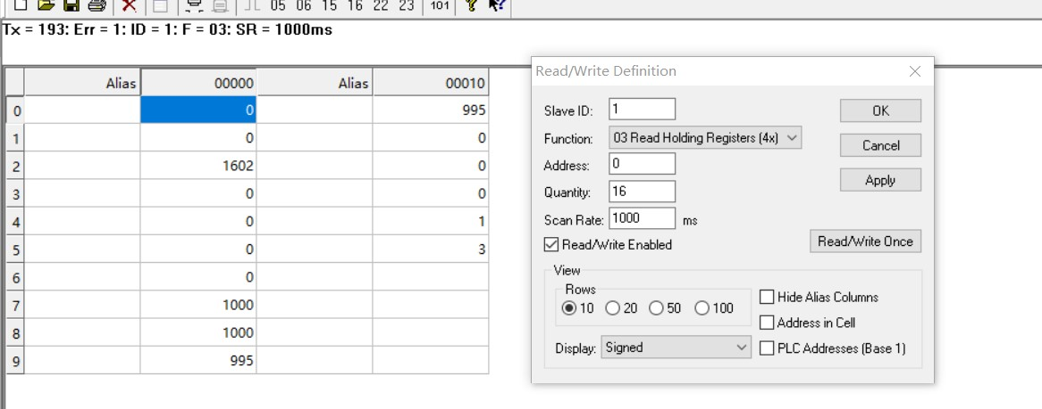

You can also use HyperTerminal serial input, as shown below

（Manually add CRC check）

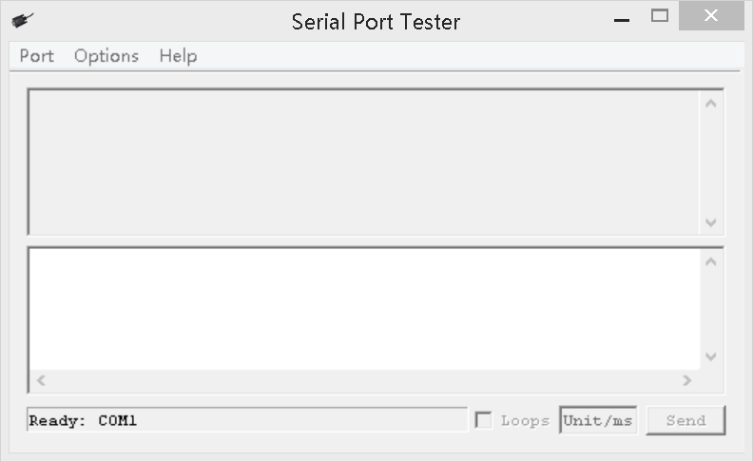

**CRC check code(C51 MCU)：**

const unsigned char code auchCRCHi[256] = {

0x00, 0xC1, 0x81, 0x40, 0x01, 0xC0, 0x80, 0x41, 0x01, 0xC0, 0x80, 0x41, 0x00, 0xC1, 0x81, 0x40,

0x01, 0xC0, 0x80, 0x41, 0x00, 0xC1, 0x81, 0x40, 0x00, 0xC1, 0x81, 0x40, 0x01, 0xC0, 0x80, 0x41,

0x01, 0xC0, 0x80, 0x41, 0x00, 0xC1, 0x81, 0x40, 0x00, 0xC1, 0x81, 0x40, 0x01, 0xC0, 0x80, 0x41,

0x00, 0xC1, 0x81, 0x40, 0x01, 0xC0, 0x80, 0x41, 0x01, 0xC0, 0x80, 0x41, 0x00, 0xC1, 0x81, 0x40,

0x01, 0xC0, 0x80, 0x41, 0x00, 0xC1, 0x81, 0x40, 0x00, 0xC1, 0x81, 0x40, 0x01, 0xC0, 0x80, 0x41,

0x00, 0xC1, 0x81, 0x40, 0x01, 0xC0, 0x80, 0x41, 0x01, 0xC0, 0x80, 0x41, 0x00, 0xC1, 0x81, 0x40,

0x00, 0xC1, 0x81, 0x40, 0x01, 0xC0, 0x80, 0x41, 0x01, 0xC0, 0x80, 0x41, 0x00, 0xC1, 0x81, 0x40,

0x01, 0xC0, 0x80, 0x41, 0x00, 0xC1, 0x81, 0x40, 0x00, 0xC1, 0x81, 0x40, 0x01, 0xC0, 0x80, 0x41,

0x01, 0xC0, 0x80, 0x41, 0x00, 0xC1, 0x81, 0x40, 0x00, 0xC1, 0x81, 0x40, 0x01, 0xC0, 0x80, 0x41,

0x00, 0xC1, 0x81, 0x40, 0x01, 0xC0, 0x80, 0x41, 0x01, 0xC0, 0x80, 0x41, 0x00, 0xC1, 0x81, 0x40,

0x00, 0xC1, 0x81, 0x40, 0x01, 0xC0, 0x80, 0x41, 0x01, 0xC0, 0x80, 0x41, 0x00, 0xC1, 0x81, 0x40,

0x01, 0xC0, 0x80, 0x41, 0x00, 0xC1, 0x81, 0x40, 0x00, 0xC1, 0x81, 0x40, 0x01, 0xC0, 0x80, 0x41,

0x00, 0xC1, 0x81, 0x40, 0x01, 0xC0, 0x80, 0x41, 0x01, 0xC0, 0x80, 0x41, 0x00, 0xC1, 0x81, 0x40,

0x01, 0xC0, 0x80, 0x41, 0x00, 0xC1, 0x81, 0x40, 0x00, 0xC1, 0x81, 0x40, 0x01, 0xC0, 0x80, 0x41,

0x01, 0xC0, 0x80, 0x41, 0x00, 0xC1, 0x81, 0x40, 0x00, 0xC1, 0x81, 0x40, 0x01, 0xC0, 0x80, 0x41,

0x00, 0xC1, 0x81, 0x40, 0x01, 0xC0, 0x80, 0x41, 0x01, 0xC0, 0x80, 0x41, 0x00, 0xC1, 0x81, 0x40

} ;

const unsigned char code auchCRCLo[256] = {

0x00, 0xC0, 0xC1, 0x01, 0xC3, 0x03, 0x02, 0xC2, 0xC6, 0x06, 0x07, 0xC7, 0x05, 0xC5, 0xC4,0x04,

0xCC, 0x0C, 0x0D, 0xCD, 0x0F, 0xCF, 0xCE, 0x0E, 0x0A, 0xCA, 0xCB, 0x0B, 0xC9, 0x09, 0x08, 0xC8,

0xD8, 0x18, 0x19, 0xD9, 0x1B, 0xDB, 0xDA, 0x1A, 0x1E, 0xDE, 0xDF, 0x1F, 0xDD, 0x1D, 0x1C, 0xDC,

0x14, 0xD4, 0xD5, 0x15, 0xD7, 0x17, 0x16, 0xD6, 0xD2, 0x12, 0x13, 0xD3, 0x11, 0xD1, 0xD0, 0x10,

0xF0, 0x30, 0x31, 0xF1, 0x33, 0xF3, 0xF2, 0x32, 0x36, 0xF6, 0xF7, 0x37, 0xF5, 0x35, 0x34, 0xF4,

0x3C, 0xFC, 0xFD, 0x3D, 0xFF, 0x3F, 0x3E, 0xFE, 0xFA, 0x3A, 0x3B, 0xFB, 0x39, 0xF9, 0xF8, 0x38,

0x28, 0xE8, 0xE9, 0x29, 0xEB, 0x2B, 0x2A, 0xEA, 0xEE, 0x2E, 0x2F, 0xEF, 0x2D, 0xED, 0xEC, 0x2C,

0xE4, 0x24, 0x25, 0xE5, 0x27, 0xE7, 0xE6, 0x26, 0x22, 0xE2, 0xE3, 0x23, 0xE1, 0x21, 0x20, 0xE0,

0xA0, 0x60, 0x61, 0xA1, 0x63, 0xA3, 0xA2, 0x62, 0x66, 0xA6, 0xA7, 0x67, 0xA5, 0x65, 0x64, 0xA4,

0x6C, 0xAC, 0xAD, 0x6D, 0xAF, 0x6F, 0x6E, 0xAE, 0xAA, 0x6A, 0x6B, 0xAB, 0x69, 0xA9, 0xA8, 0x68,

0x78, 0xB8, 0xB9, 0x79, 0xBB, 0x7B, 0x7A, 0xBA, 0xBE, 0x7E, 0x7F, 0xBF, 0x7D, 0xBD, 0xBC, 0x7C,

0xB4, 0x74, 0x75, 0xB5, 0x77, 0xB7, 0xB6, 0x76, 0x72, 0xB2, 0xB3, 0x73, 0xB1, 0x71, 0x70, 0xB0,

0x50, 0x90, 0x91, 0x51, 0x93, 0x53, 0x52, 0x92, 0x96, 0x56, 0x57, 0x97, 0x55, 0x95, 0x94, 0x54,

0x9C, 0x5C, 0x5D, 0x9D, 0x5F, 0x9F, 0x9E, 0x5E, 0x5A, 0x9A, 0x9B, 0x5B, 0x99, 0x59, 0x58, 0x98,

0x88, 0x48, 0x49, 0x89, 0x4B, 0x8B, 0x8A, 0x4A, 0x4E, 0x8E, 0x8F, 0x4F, 0x8D, 0x4D, 0x4C, 0x8C,

0x44, 0x84, 0x85, 0x45, 0x87, 0x47, 0x46, 0x86, 0x82, 0x42, 0x43, 0x83, 0x41, 0x81, 0x80,0x40

} ;

unsigned int CRC_16(unsigned char *str,unsigned int usDataLen)

{

unsigned char uchCRCHi = 0xFF ; /* high byte of CRC initialized */

unsigned char uchCRCLo = 0xFF ; /* low byte of CRC initialized */

unsigned uIndex ; /* will index into CRC lookup table */

while (usDataLen--)/* pass through message buffer */

{

uIndex = uchCRCHi ^ *str++ ; /* calculate the CRC */

uchCRCHi = uchCRCLo ^ auchCRCHi[uIndex];

uchCRCLo = auchCRCLo[uIndex] ;

}

return (uchCRCHi << 8 | uchCRCLo) ;

}